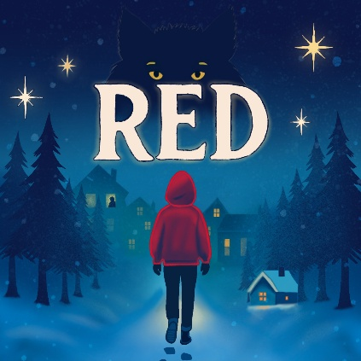

Ice Lolly Order Form

Dear Group Leader

To facilitate the ordering and distribution of ice lollies to large groups during the school performances, it would be helpful to know in advance if you wish to place an order.

Please indicate your requirements and return the completed form to us at least 14 days before the date of the performance. (Unfortunately we cannot guarantee to meet orders placed later than this.)

Item | Price (each) | Quantity required | TOTAL DUE
Pip Organic Berry Fruity Ice Lolly | £1.00 |  | £
*Please see overleaf for ingredients and allergy information

Name of School/Group: __________________________________________________

Date/Time of Performance: _______________________________________________

Please make cheques payable to “Chickenshed Trading Limited”
If you wish to pay via bank transfer our bank details are as follows:
(please note that this is a different account to the one for tickets)
Account: 35376526
Sort Code: 23-05-80
Name: CHICKENSHED TRADING LIMITED
Please send remittance to accounts@chickenshed.org.uk

Please return this order form to:
Chickenshed Box Office, Chase Side, London N14 4PE
Tel: 020 8292 9222, Email: bookings@chickenshed.org.uk

Office use only
Date Order Received:
Payment Received:

PIP Organic Berry Fruity Ice Lolly
Ingredients; Organic apple juice (39%), organic apple puree (20%), organic strawberry puree (15%), organic grape juice (15%), organic blackcurrant puree, organic guar gum - which is a plant extract & natural thickener.

Allergy information: Dairy, Lactose & Nut Free. Suitable for vegetarians

